**WE ARE BRUIN S.T.R.O.N.G.!**

To accomplish the Briggs Mission the staff and students will focus on being **Bruin S.T.R.O.N.G.** We believe that when these characteristics are demonstrated throughout the school it creates a positive learning environment for all and builds a strong sense of community.

**S** = Support One Another **T** = Trustworthy **R** = Respectful **O** = Open Minded **N** = Never Give Up **G** = Growth Focused

**WE ARE BRUIN S.T.R.O.N.G. DURING AN ASSEMBLY**

**S** – We **Support One Another** by entering the assembly in an orderly and quiet manner and move with our class to our assigned area.

**T** – We are **Trustworthy** by sitting in our assigned areas and listening to our teacher’s instructions and the instructions of the presenter.

**R** – We are **Respectful** by listening attentively to the presenter, not talking during the presentation, and engaging in appropriate responses.

**O**- We are **Open Minded** by listening and being respectful to the presenter even if I disagree with what they are saying.

**N** – We **Never Give Up** by staying attentive throughout the entire presentation.

**G** – We are **Growth Minded** by considering how the information being presented can apply to our own lives and help us grow.

**WE ARE BRUIN S.T.R.O.N.G. IN THE HALLWAYS**

**S** – We **Support One Another** by staying to the right of the hallway/stairwell and helping each other get to class on time.

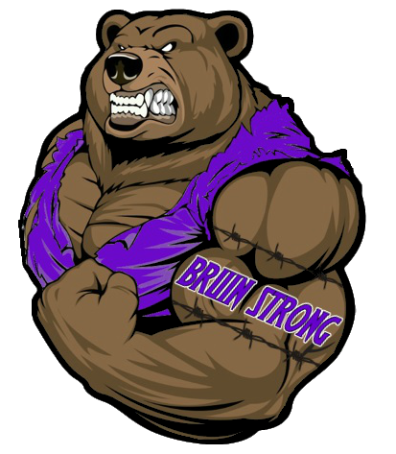**T** – We are **Trustworthy** by following school rules even when no one is looking (i.e. headphones).

**R** – We are **Respectful** by using positive language not using profanity or insulting people.

**O**- We are **Open Minded** by being friendly to people even if we don’t know them.

**N** – We **Never Give Up** by continuing to move to class and not stopping in the hallway which blocks the flow.

**G** – We are **Growth Minded** by responding positively to interactions with others. 8/21/2017 7:01:11 PM

**WE ARE BRUIN S.T.R.O.N.G. IN THE CLASSROOM**

**S** – We **Support One Another** by working collaboratively with peers and with the teachers.

**T** – We are **Trustworthy** by respecting people’s personal space and personal items.

**R** – We are **Respectful** by honoring a reasonable teacher request in a reasonable amount of time.

**O**- We are **Open Minded** by accepting other people’s ideas without judgment.

**N** – We **Never Give Up** when the work gets hard.

**G** – We are **Growth Minded** by learning from our mistakes.

**WE ARE BRUIN S.T.R.O.N.G. IN THE CAFETERIA**

**S** – We **Support One Another** by lining up in the lunch line in an orderly manner.

**T** – We are **Trustworthy** by respecting people’s personal space and personal items.

**R** – We are **Respectful** by cleaning up after ourselves.

**O**- We are **Open Minded** by appreciating food that is different from what we typically eat.

**N** – We **Never Give Up** by remaining calm throughout the entire lunchtime.

**G** – We are **Growth Minded** by meeting new people and welcoming others to our table.